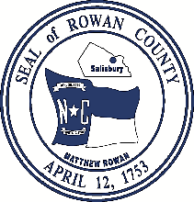
Greg Edds, Chairman Aaron Church, County Manager
Jim Greene, Vice- Chairman Carolyn Barger, Clerk to the Board
Mike Caskey John W. Dees, II, County Attorney
Judy Klusman
Craig Pierce

Rowan County Board of Commissioners
130 West Innes Street ∙ Salisbury, NC 28144
Telephone 704-216-8180 ∙ Fax 704-216-8195

NOTICE OF SPECIAL CALLED MEETING
OF THE ROWAN COUNTY BOARD OF COMMISSIONERS

Notice is hereby given that the Chairman of the Rowan County Board of Commissioners has called for a Special Meeting to be held on Tuesday, July 21, 2020 at 6:00 p.m.
The purpose of the meeting will be to consider approval of a lease at Mid-Carolina Airport and to discuss use of architectural funds through the Coronavirus Relief Fund (CRF) for Rowan County’s municipalities.
Given the COVID-19 Pandemic the meeting will be held by virtual means. Interested persons may join the meeting at https://bit.ly/rowanboc0721 using Password: 07212020 or by phone dialing any one of the following phone numbers: (720) 928-9299 or (213) 338-8477 or (602) 753-0140 and, when prompted, enter Meeting ID 971 0569 5623 and Password 07212020.
This the 16th day of July, 2020.

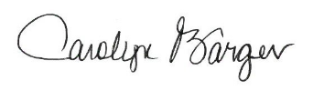
Carolyn Barger, MMC, NCMCC
Clerk to the Board

