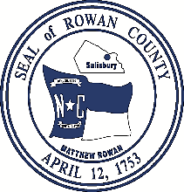
Greg Edds, Chairman Aaron Church, County Manager
Jim Greene, Vice-Chairman Sarah Pack, Clerk to the Board
Daniel Lancaster John W. Dees, II, County Attorney
Judy Klusman
Craig Pierce

Rowan County Board of Commissioners
130 West Innes Street ∙ Salisbury, NC 28144
Telephone 704-216-8180 ∙ Fax 704-216-8195

NOTICE OF A CHANGE TO THE
ROWAN COUNTY BOARD OF COMMISSIONERS
JULY MEETING SCHEDULE

The Rowan County Board of Commissioners has canceled its regular meeting scheduled for July 7, 2025, at 3:00 p.m.

The change will be for the month of July only and will not affect the regularly scheduled times of future meetings.

This the 17th day of June 2025.

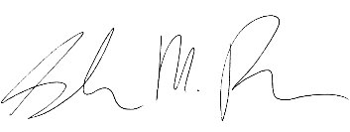
Sarah Pack, NCCCC
Clerk to the Board

Equal Opportunity Employer

