NOTICE OF PUBLIC HEARING

NOTICE is hereby given that the Rowan County Board of Commissioners will hold a public hearing in the J. Newton Cohen, Sr. Room on the second floor of the J. Newton Cohen, Sr. Rowan County Administration Building in Salisbury, North Carolina, beginning at 3:00 PM or as soon thereafter as may be heard, on Monday, June 30, 2025, on the following:

In accordance with North Carolina General Statute §158-7.1(c), the purpose of the hearing will be to receive public comments on a proposed incentive offer to Project Powerball, a company proposing to establish operations in Rowan County.

Project Powerball is expected to (1) create a significant investment in real estate and equipment, approximately $264 million, and (2) create 1,181 full-time jobs over the next five years.
The proposed incentive offer consists of an assistance grant with a total value of approximately $2,307,414 paid over a term not to exceed five years.

The County will recover the cost and the public will benefit through future property and business taxes, stimulation of the economy, promotion of business and the creation of jobs in Rowan County.

All persons interested in this incentive are invited to attend this public hearing and present their views.

This, the 17th day of June 2025.
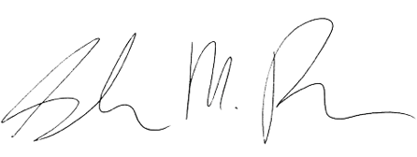
Sarah Pack, NCCCC
Clerk to the Board

