NOTICE OF SPECIAL MEETING OF THE
ROWAN COUNTY BOARD OF COMMISSIONERS

Notice is hereby given that the Chairman of the Rowan County Board of Commissioners has called for a Special Meeting to be held on Monday, June 30, 2025, at 3:00 p.m.

The meeting will convene in the J. Newton Cohen, Sr. Room on the second floor of the J. Newton Cohen, Sr. Rowan County Administration Building, located at 130 West Innes Street, Salisbury, NC.

The purpose of the meeting will be to discuss the continuation of overtime pay for patrol and detention officers, to consider a change order for the hangar expansion project, and to hold a public hearing on a proposed incentive offer to Project Powerball, a company proposing to establish operations in Rowan County.

This the 20th day of June 2024.
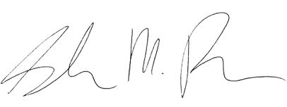

Sarah Pack, NCCCC
Clerk to the Board

